Scope of Delivery
for delivery of the GENSET 4500 or 4300
based on the MWM TCG 2032 V16 (B) 50Hz gas engine

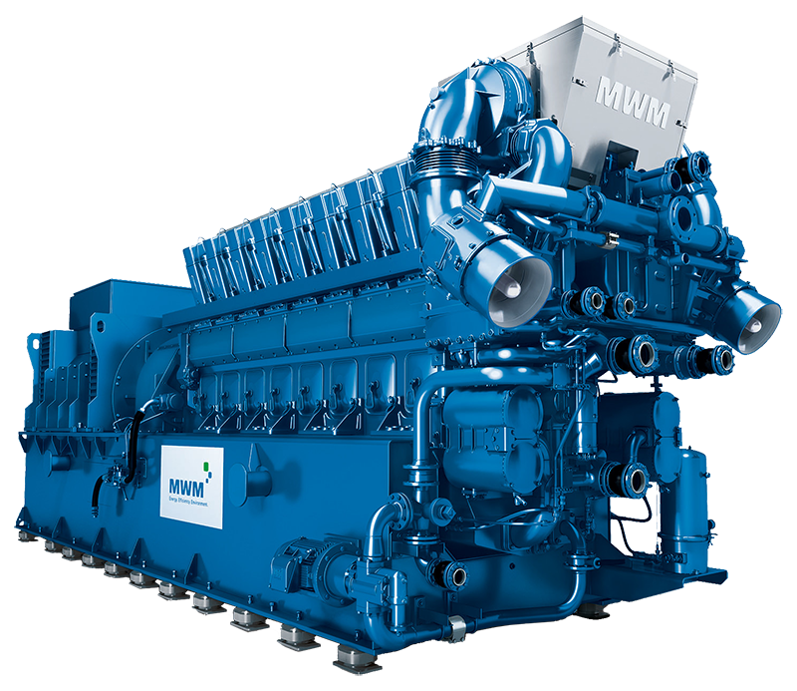

Schematic Process Flow Chart

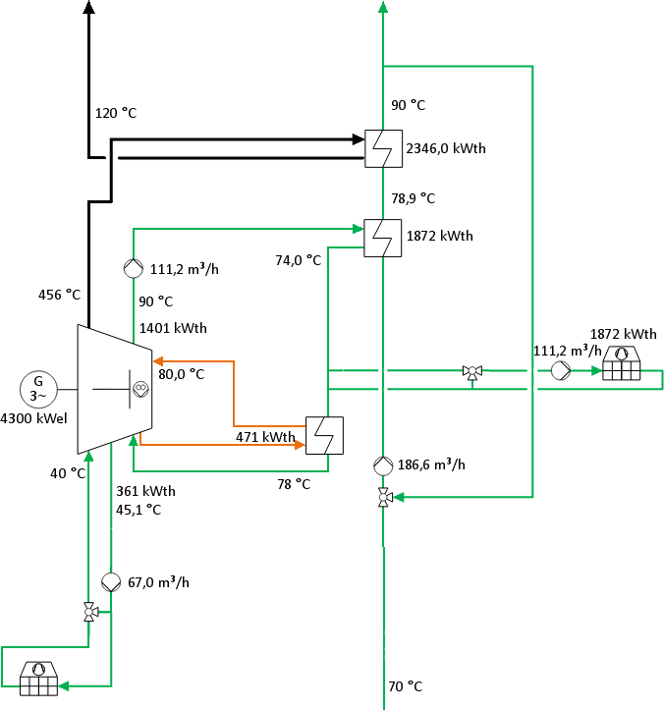

Scope of supply

Overview

Number | Title
Genset
Engine Parts
1 | Engine configuration
1 | Basic parts
1 | Exhaust gas system
1 | Exhaust expansion joint
1 | Exhaust turbo charger
1 | Cooling system
1 | Torsional vibration damper
1 | Fly wheel
1 | Starter equipment
1 | Engine Mounting
1 | Speed and load regulation
1 | Ignition device
1 | Gas mixer
1 | TEM Engine monitoring and control
1 | Primer and Topcoat Engine - Primer
1 | Conservation
1 | without spare parts for commissioning
Mixtrure Piping
1 | Gas mixture pipe without compressor cooling
Lubrication System
1 | Lube oil system
Genset Parts
1 | Genset defintion
1 | Generator - Marelli MJH 800 MC6 / TDPS TD 145
1 | Base frame without integrated oil tank
1 | Elastic genset mounting
1 | Elastic coupling
1 | Fasteners
1 | Crankcase ventilation
1 | Piping (plain bearing)
1 | Coolant preheat V
1 | Coolant expansion joints water / oil
1 | Pre Lubrication Genset - 400 / 690 / 460 V
1 | Additional parts for lubrication system 230 V
1 | Air filter, lateral air supply, with console
1 | Caps for gas connection

1 | Compressed air control train
Primer and Topcoat for Genset
1 | Primer and Topcoat for Genset - RAL 5010, gentian blue
Spare Paint
1 | Repair Paint - RAL 5010, gentian blue
Name Plates for Complete Engine
1 | Labeling of the genset - English (US)
Genset Test
1 | Genset acceptance test without customer participation
Packing for Complete Genset
1 | Packing suitable for overland transport for genset: foil cover
Fuel System
Zero-Pressure Gas Control Train
Gas Train
1 | Gas train DN 125/125 - with seal monitoring unit
Connecting Accessories for Zero Pressure Train
1 | Compensator for gasconnection
Heating System
Engine Cooling Circuit
Lube Oil Heat Exchanger
1 | Lube oil heat exchanger
1 | Counter flange DN 100 - steel/stainless steel
Sensors and Accessories
1 | Gas and dirt separator DN 125
1 | Counter Flange Set DN 125 - Set of 2
Exhaust Gas System
Sensors
1 | Exhaust back pressure sensor
Electrical System
Genset Management (TEM)
Base System
1 | TEM - Basic Cabinet (ST32-F)
1 | TEM packaging in wooden crate (VER)
Power Plant Control System
1 | Heat utilization with heating circuit (HK2)
1 | Radiator controler (TKS1)
1 | Acknowledgment of external monitoring (QEÜ)
1 | Cabin air regulation (RL1)
1 | Demand of external starting preparations (AES)
1 | Handling of mains failure (NA)
1 | Dump cooling and exhaust bypass control (NK/BY)

Parameterizable Input/Output
1 | 2 parameterizable measurements (2MW)
1 | 1 parameterizable control circuit (1PR)
Interface
1 | Analog speed setting (ASD)
1 | Remote Engine Management
Hardware
1 | I/O Controller (IOC) (included in Base system)
1 | Operating terminal (BRT)
1 | wall switch cabinet, Height 1200mm door hinge right (AE0R)
1 | Console (KBW)
1 | TEM connecting cable set 8m (K32ARM)
Packing
Plant Components
1 | Packing plant components
Documentation
Documentation First language
1 | Documentation first language - standard documentation
1 | Data volume copy
Documentation
1 | Standard documentation incl. TEM documentation

