501-KB7S Mobile Generator Sets

HALLIBURTON ENERGY SERVICES

TECHNICAL PROPOSAL INDEX

Section 1.0 Commercial Details
  - Commercial Offering
  - Contract Change Orders
  - Progress Payment Schedule
  - General Terms and Conditions
  - Field Services
  - Typical Maintenance Schedule
  - Comments & Exceptions
  - Gas Turbine Genset Bill of Materials

Section 2.0 Project Implementation
2.1 Preliminary Project Schedule
2.2 Equipment Photos
2.3 Project Management
2.4 Major Supplier List
2.5 Codes and Standards
2.6 Protective Coatings Specification

Section 3.0 Package Performance
3.1 Gas Turbine/Generator Performance

Section 4.0 Technical Descriptions
4.1 Gas Turbine Description
4.2 Speed Reduction Gearbox Description
4.3 Generator Description
4.4 Fluid Systems Description
4.5 Turbine/Generator Control Panel Description
4.6 Switchgear
4.7 Ancillary Equipment

Section 5.0 Proposal Drawings
5.1 General Arrangement Drawing
5.2 Piping and Instrument Diagrams
5.3 Typical Single-Line Diagram [Later]
5.4 Package Electrical Utility Load List
5.5 Package non-Electrical Utility Load List
5.6 Document List
1.0 Commercial Details

  - Commercial Offering

Commercial details are provided in the Commercial Proposal and this document is focused on the Technical aspects of the Mobile Generator Set (Genset).

1.2 Contract Change Orders

In the event that changes are required to the Genset configuration as covered in the Technical Proposal including additional material and or labor due to the prototype configuration being adapted to address evolving field service requirements, then additional work items shall be quoted as a separate change order to the original contract. Effect on delivery will be identified in the new quotation if a change is required.

1.3 Progress Payment Schedule

Progress Payment Schedule is provided and covered in the Commercial Proposal Document.

1.4 General Terms and Conditions

General Terms and Conditions are addressed in the Commercial Proposal Document.

1.5 Field Services

Field services include but are not limited to the execution of schedule maintenance procedures required for the Genset on an ongoing basis. The Genset and associated equipment shall be installed, leveled, and operated at the expense of the Purchaser.

Siemens shall not be responsible for materials furnished by the Purchaser or for acts or failures to act of personnel furnished by the Purchaser, nor shall be responsible for foundation or for the nature of the soil upon which the generators are setup and operated.

Field Service Terms

In the event Seller is to provide any services on site, such as, but not limited to inspection, installation, construction, supervision or training, the following conditions shall apply:

- Buyer shall provide assistance to Seller as may be necessary or reasonable to enable Seller to complete its work on site. Such assistance shall include without limitation provision of electric power, water and other utilities, reasonable security and protection for equipment, property and persons, access to roads and means of transport, fuels and lubricants in quantities sufficient to meet the requirements of the order including testing, permits and licenses.

- In the event Buyer or its employees, agents, subcontractors or other representatives are required to perform services at a remote site, in offshore waters or at any location outside the United States,, Buyer shall provide at no cost to Seller, all transportation for such persons from an agreed staging point to and from the site, all housing, food, facilities and medical care while at the site, and all transportation and any handling equipment necessary to transfer the goods, tools and equipment to the site.

- In the event Seller’s employees, agents, subcontractors or other representatives are to perform services outside the United States, Buyer shall assist in their movement within or from any country where they are to perform, including without limitation, assistance in obtaining necessary visas and permits. Buyer shall be responsible for the payment of any applicable income or other taxes and other employee fees and assessments.

1.6 Siemens 501-KB7S Gas Turbine Maintenance Plan

Inspection Interval Downtime Manpower
Type (hours) Required Requirement

Quarterly 2,000 1 Day, 12 Hours 1 Service Technician
24 Hours Downtime

Semi-Annual 4,000 1 Day, 12 Hours 1 Service Technician
24 Hours Downtime

Quarterly 6,000 1 Day, 12 Hours 1 Service Technician
24 Hours Downtime

Annual 8,000 2 Day, 12 Hours 2 Service Technician
48 Hours Downtime

Quarterly 10,000 1 Day, 12 Hours 1 Service Technician
24 Hours Downtime

Semi-Annual 12,000 1 Day, 12 Hours 1 Service Technician
24 Hours Downtime

Quarterly 14,000 1 Day, 12 Hours 1 Service Technician
24 Hours Downtime

Annual 16,000 2 Day, 12 Hours 2 Service Technician
48 Hours Downtime

Quarterly 18,000 1 Day, 12 Hours 1 Service Technician
24 Hours Downtime

Semi-Annual 20,000 1 Day, 12 Hours 1 Service Technician
24 Hours Downtime

Quarterly 22,000 1 Day, 12 Hours 1 Service Technician
24 Hours Downtime

Annual 24,000 2 Day, 12 Hours 2 Service Technician
48 Hours Downtime

Quarterly 26,000 1 Day, 12 Hours 1 Service Technician
24 Hours Downtime

Semi-Annual 28,000 1 Day, 12 Hours 1 Service Technician
24 Hours Downtime

Quarterly 30,000 1 Day, 12 Hours 1 Service Technician
24 Hours Downtime

Annual 32,000 2 Day, 12 Hours 2 Service Technician
48 Hours Downtime

Quarterly 34,000 1 Day, 12 Hours 1 Service Technician
24 Hours Downtime

Inspection Interval Downtime Manpower
Type (hours) Required Requirement

Semi-Annual 36,000 1 Day, 12 Hours 1 Service Technician
24 Hours Downtime

Quarterly 38,000 1 Day, 12 Hours 1 Service Technician
24 Hours Downtime

Annual 40,000 3 Day, 12 Hours 2 Service Technician
(Overhaul) 72 Hours Downtime

1.7 Comments & Exceptions
Scope:
This specification defines the general design requirements for a mobile power generation unit using a gas turbine (GT) as the prime mover operated in simple cycle. The primary usage shall be to drive three Halliburton - Q10 quintuplex positive displacement pump trailers in concert with their variable-frequency AC drives and motors for use in land-based oil well fracturing services.

Performance Ratings of the GTG Unit:
• Output power to be 5 MW class with 3500 kW minimum at 6000 ft. and 33 °C
Please refer to detailed Genset performance as outlined in Section Three of this proposal.
• GT to be single shaft design and proven, lightweight aero-derivative design
• Dry Gas fuel system with DLE combustors
• Emissions to meet EPA 40 CFR Part 60, section KKKK for gas turbines
• Sound levels as defined in ISO 3744, 2010 edition.
• Standard package to meet 76 dBC at 350’
• Optional package to meet 59 dBC at 350’
• Gearbox designed to latest API std. to take output power down to 1800 rpm
Exception- Gearbox designed with AGMA 1.3 service factor
• Generator sized to handle full load, plus harmonics & low power factor of 6-pulse drives
• Nameplate rated 3000 VAC, 3ph, 4-pole, air-cooled unit
Exception- Generator Voltage to be 2600Vac L-L
• Windings designed with class F insulation with a Class B rise at 40 °C
Exception- Generator nameplate rating is based on Class-F rise at 40°C ambient
• Generator to have High Resistance grounding system limited to 10 amps with monitor
• Excitation system will be brushless, PMG (Permanent Magnet Generator) with digital voltage regulator system
• GTG unit will be able to pick-up or reject rated full load of one of the pumps
• Local control system with automatic voltage regulator and governor included
• Switchgear lineup to include a main breaker or fused contactor with 3 feeder breakers or fused contactors for the 3 pump trailers
Exception- Per Siemens design, 2.6kV Switchgear will include 3 Feeder Breakers for the 3 pump trailers. Main breaker requirement has been deleted based on discussions with Halliburton with relation to the island mode operations. Switchgear is covered in Section 4,6 in this proposal.

Construction:
• GTG unit and all aux systems will be trailer mounted on one trailer per unit
• No lifting equipment shall be needed to set-up the unit on site
Exception- Lifting required for the optional roof mounted exhaust silencer
• Trailer and package will be able to handle high G loading over rough roads
Comment-
Due to the infeasibility of shake table testing a unit the size of the trailer mounted GTG equipment, OPI has elected to design and analyze the proposed unit based on the experience of Mertz Manufacturing. Mertz is the proposed trailer supplier for this unit. OPI will incorporate their experience for supplying machinery-mounted trailers for the oil and gas industry to set the design criteria. In our collective mobile oil and gas and power industry rotating machinery project history OPI, and our primary vendors have never been required to consider

seismic and transport loading at frequency and amplitude levels approaching the criteria specified in Halliburton shock and vibration standard D00504124. Therefore, OPI proposes the following design criteria for this project: Trailer and GTG baseplate will be analyzed and designed for the static loadings below:
- 1 G fore – aft
- 1 G lateral
- 2 G vertical
• Package will contain all aux. equipment needed to run the package including: air filtration package, lube oil systems, air cooling, starting system, fire and gas system
• Forced air cooled using auxiliary blower and ambient air preferred
• Air filtering for high dust environment and a gas sensor included to detect a large gas leak at the site to shut down the unit at 20 LEL level for NG
• All GTG auxiliary power motors to be rated for 480Vac @ 60Hz, plus 240/120 volts for single phase loads like lights, control & fire and gas systems, duplex outlets, etc.
• 3 – 480 volt feeders, one for each pump trailer to provide start-up power for the controls and pre-charge of the cap banks in the drives before main power is turned on from the
3000 volt contactor in the GTG unit
Exception- This is no longer required, or part of Siemens power distribution system, and will not be necessary.
• Space heaters included as needed for cold temps
• Lube oil system for all major components
• Lifting and rail system to change out the gas turbine for overhauls
• Weather proof enclosures for all major GTG components
• Internal and external lighting system using LED technology
• Control system and batteries included on the trailer with local interface

Environmental Ratings:
• Assembly protection to be IP56 minimum
• Able to withstand environmental conditions of spec D00504124, see appendix C
Exception to this specification
Details of component qualification and design criteria will be discussed with the Halliburton Engineering specialists to ensure that the prototype Gensets are able to meet the expectations of field service.
• -35C to 45C operating temperature range
Exception- -28C to 45C
The limitation is based on the generator rotor journals which require heater elements to ensure that the generator can be turned and have load applied during rotation at temperatures below -28°C. This limitation can be overcome through the use of different material for the generator rotor and the inclusion of heating elements in the generator castings supporting the rotor assembly. The option is identified in the pricing paragraph in the proposal document.
• 0-6000ft-asl

Wiring Connections:
• MV quick connect cabling for main power at 3000 volts on back of the package
• LV quick connect cabling for Black Start Unit also on the back, or on both sides
• Control and Instrument quick connect cabling for interface with HAL system
• Grounding bosses on frame and bonded with the trailer
• Quick connect for grounding trailers together into a common ground grid

Tagging information:
• Standard nameplate
• Tagging, labeling and documentation to be in English
• Tag material to be stainless steel w/ drive screw attachment

Testing:
• Per API, ANSI, NEMA, IEEE STDs and Siemens testing requirements.
Exception- Factory Testing will be per OPI Standard Procedure for 501 KB/KH Gen Set No. 90357
• Complete unit will meet Halliburton shock and vibration standard D00504124
Exception- Trailer and GTG baseplate will be analyzed and designed for the following static loading:
- 1 G fore – aft
- 1 G lateral
- 2 G vertical
No environmental component testing will be conducted on equipment
Electromagnetic Interference Testing – Not defined at this time.

Production documentation:
• Complete Test report and O&M Manuals

A letter of documentation identifying serial number, Halliburton part number, PO Number and Test
Report to be sent to:

Quality Assurance Manager Halliburton Energy Services Duncan Manufacturing Center
100 East Halliburton Blvd
Duncan, OK 73536
FDUNRECCERT@Halliburton.com

RFI/RFQ Documentation:
• Specification exceptions and alternatives
• 3D Model of GTG package and trailer
• Dimensional Drawing w/ weight and CG location
• All GTG Package Drawings
Exception- As defined in OPI proposal #0223
• All Study Reports
Exception- As defined in OPI proposal #0223
• Wiring Diagrams
Exception- As defined in OPI proposal #0223
• GTG performance data/graph
• Service/Maintenance, Operation manuals
• Installation and Application documentation

_____________________________________
1.8 Bill of Material Gas Turbine Generator Package

The Gas Turbine Generator Package will include the following drive train, equipment that are mounted on the structural baseplate as well as components and systems that are mounted on or within the package enclosure.

- Siemens Aeroderivative Industrial Gas Turbines.
- Model 501-KB7S – 5220KW @ ISO Conditions No Losses.
- Allen Gear Epicyclic Design Reduction Gearbox face mounted to Generator.
- 8.105 gear ratio, 1.3 AGMA service factor
- Ideal Electric Synchronous Generator designed to NEMA standard MG 1
- Brushless Exciter and Permanent Magnetic Alternator.
- Open drip-proof enclosure
- NEMA Class F insulation temperature rise (105°C above 40°C ambient)
- 2,600 volt, 3 phase, 60 hertz, 1,800 rpm
- Generator high voltage terminal box including direct connection to power distribution switchgear bus
- Current transformers (CT’s).
- Siemens Switchgear
- Model NXPLUS C Medium Voltage Switchgear
- Hermetically welded enclosure
- No maintenance and repair cycles required
- No need to check the gas quantity and quality due to welded stainless steel enclosures.
- Degrees of protection by enclosure

- Gas Fuel System, natural gas fuel turbine nozzles and manifold.
- Double block and single vent valves.
- Natural gas fuel control valve.
- In-line natural gas fuel filter.
- Natural gas fuel supply pressure regulator.
- Dry Low Emissions (DLE) combustion reduction system.
- Electric start system, start motor gearbox mounted with overrunning clutch.
- Common synthetic lube oil system for gas turbine, gearbox and generator.
- Shaft driven main oil pump
- Electric motor driven auxiliary / pre-lube
- Duplex lube oil filter with differential pressure gauge / switch
- Lube oil reservoir with electric immersion heater
- Air cooled heat exchangers with thermostatic valve
- Fire suppression and gas detection system for the gas turbine enclosure.
  - CO2 piping system
  - CO2 discharge nozzles
  - Combustion gas sensors for GTG and combustion air inlet
  - Thermal detectors
  - U-V/IR model 40/40 detectors
  - Alarm horn and strobe
- Manual pull stations
- On-line and crank soak turbine compressor water wash cleaning system
- On-line spray nozzles
- Crank soak spray nozzles
- In-line strainer, check valves and isolation valves
- Drive train instrumentation system
- Turbine air inlet RTD
- Turbine compartment RTD
- Generator bearing RTD’s
- Generator stator winding RTD’s
- Generator space heater
- Gas turbine, gearbox and generator seismic pick-ups

- Gas turbine speed pick-ups
- Gas turbine exhaust thermocouples
- Turbine air inlet pressure gauges, switches and transmitter
- Instrument air system
- Ventilation dampener actuation - pneumatic cylinders
- Ventilation dampener actuation - 3-way solenoid valves
- Turbine compressor bleed valve actuation – 3-way solenoid valve
- Fuel system control – 3-way solenoid valves
- Low voltage and control.
- Wiring from all package systems terminate within local control panel.
- Acoustical post and beam enclosure with roof, wall sections and access doors. Turbine enclosure light fixtures and service receptacles.
- Gas Turbine maintenance removal hoist.
- Ventilation air flow system including;
- Vaneaxial ventilation inlet fans mounted within gas turbine roof.
- Generator ventilation discharge louver and silencer
- Electric start motor variable frequency drive.
- Turbine Exhaust Diffuser and Expansion Joint
- Turbine exhaust silencer with exhaust stack mounted to trailer.
- (2) 15’ turbine exhaust silencer extensions w/ accompanying inlet/outlet elbows
- Turbine compressor water wash cart (1 per site)
- Gas Turbine and Generator Controls, including instrument monitoring, protection and control, generator metering, protective relays and automatic voltage regulator.
- Control Power Batteries and Battery Charger
- 5 axel transport trailer manufactured by Mertz Manufacturing, Oklahoma
- Neutral high resistance grounding transformer/resistor.
- 4Kv Class electrical generator/pump switchgear including PT’s, CT’s and protective relays
- 480v auxiliary power transformer for parasitic loads
- Motor control center

Components and services not included by On Power to be provided by Halliburton:

- Installation of gas turbine generator set package.
- Installation of roof mounted exhaust silencer sections/elbows.
- Black start 250 KW 312 KVA 480 volt 3 phase 60 hertz Diesel Engine Generator Set
- Diesel engine and generator controls
- Engine exhaust muffler
- Generator circuit breaker
- 480 volt 3 phase 300 amp power supply cable to GTG
- Natural gas fuel booster compressors.
- Natural gas fuel filter / coalescer (10 micron).
- Natural gas fuel conditioning skid.
- Interconnecting piping between the gas turbine generator package for the natural gas fuel supply
- Interconnecting control cables between the gas turbine generator package, pump skids, and site control room
- Instrumentation/shop compressed air described in Section 4.4.8
- Access Service Platforms for field servicing of Genset

_________________________________________

Section 2.0 Implementation Proposal

2.1 Preliminary Project Schedule
2.2 Equipment Photos
2.3 Project Management
2.4 Permits and Approvals
2.5 Supplier List
2.6 Codes and Standards
2.7 Protective Coatings

  - Preliminary Project Schedule

Refer to attached Schedule as part of the Project Management Package offer.

2.2 Equipment Models and Pictures

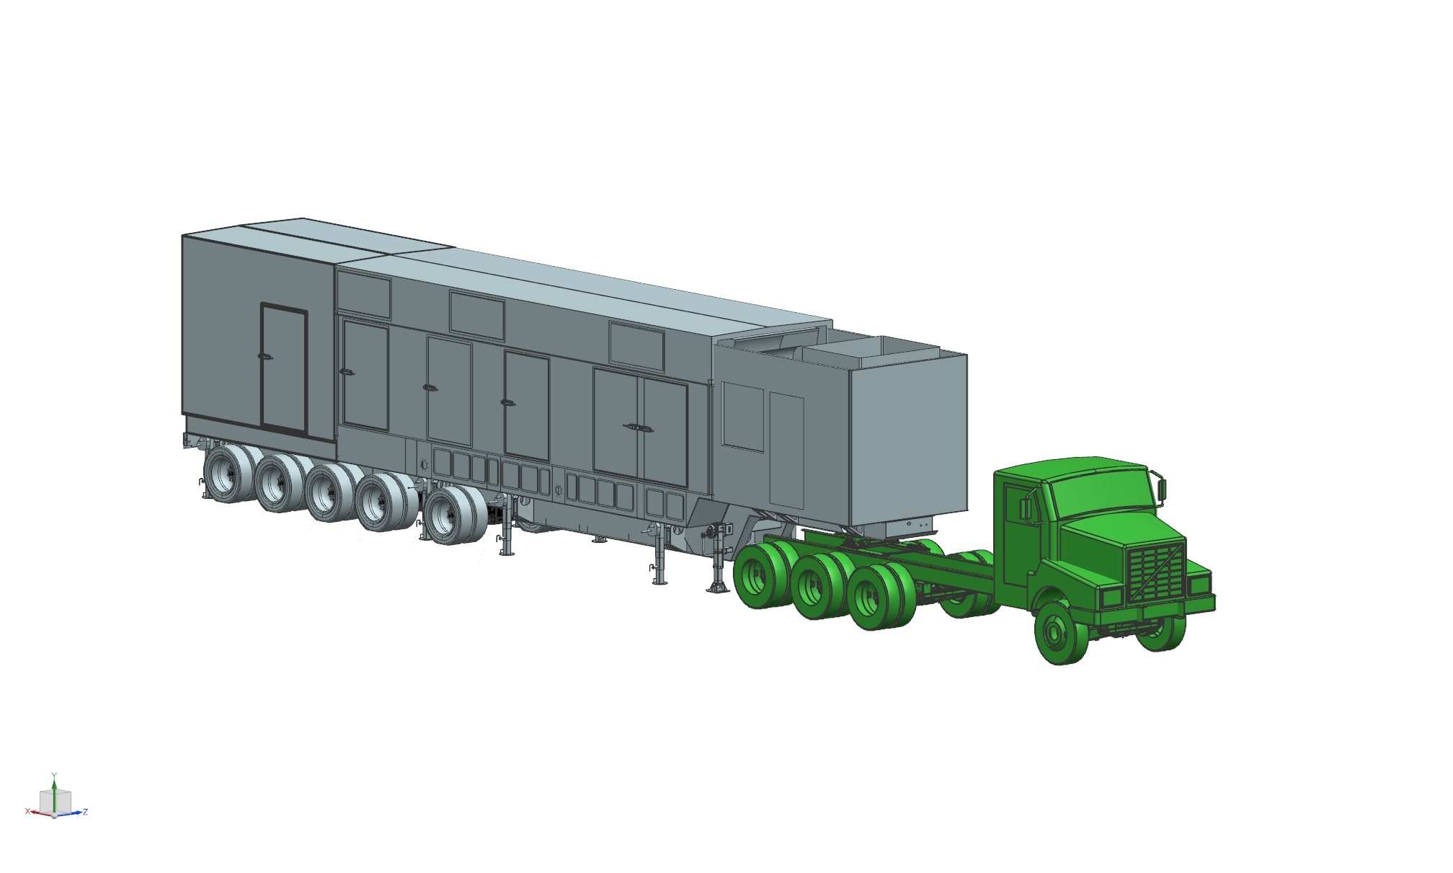

Mobile Genset Package
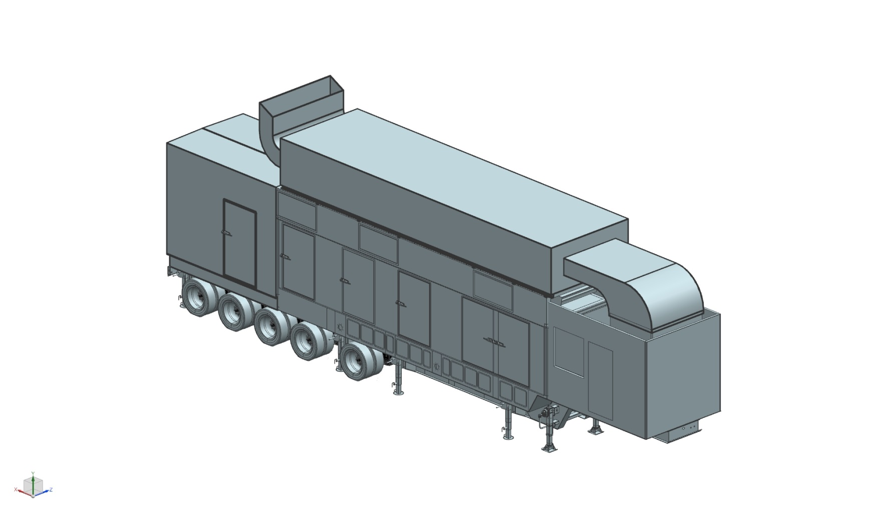
Isometric View of Mobile Genset with Option Silencer installed

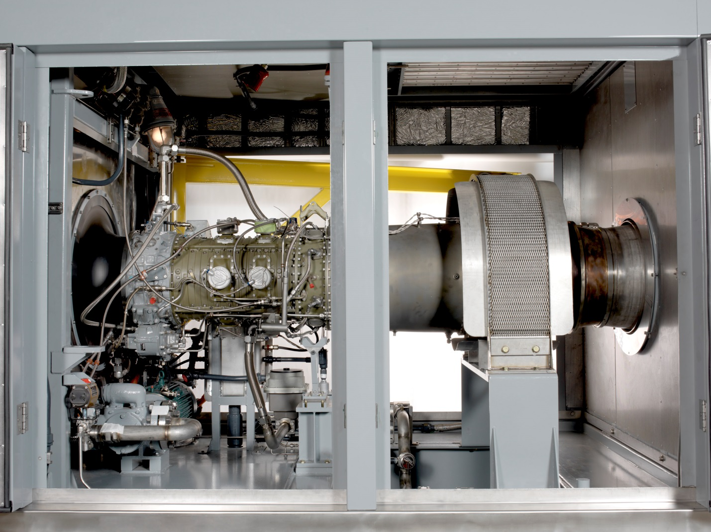

501-K Gas Turbine

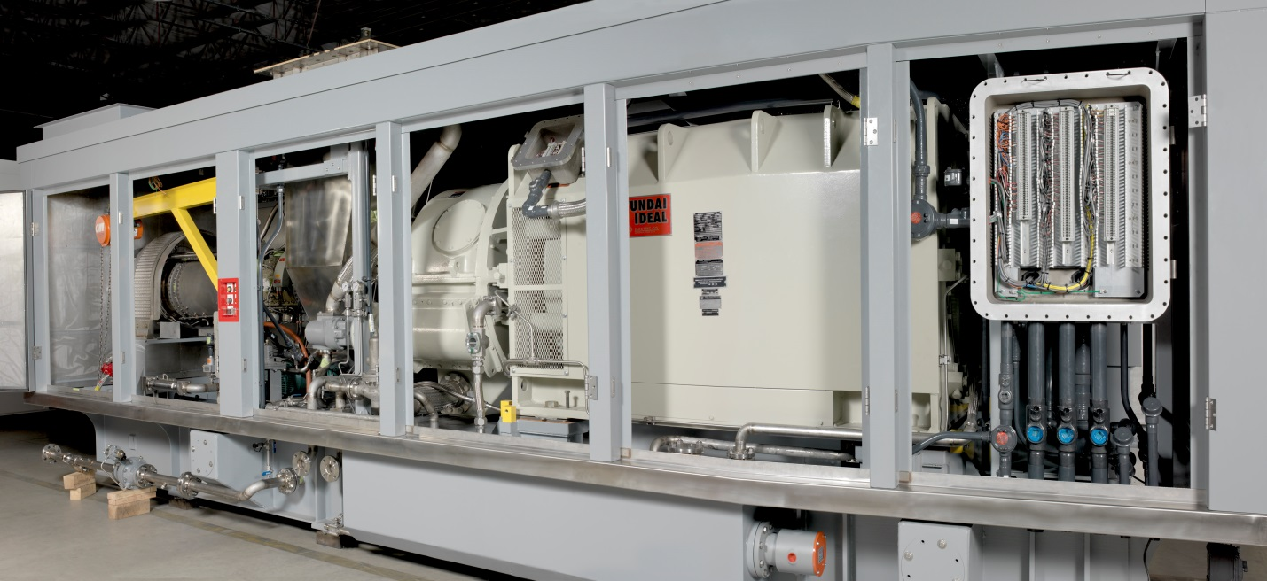

Gas Turbine Generator Package Door Removed

2.3 Project Management

Dresser-Rand and On Power’s in-house staff will manage the design, engineering, procurement, assembly and testing of the gas turbine generator package. Our Project Management and Engineering staff will manage the drawing and document submittals, design reviews, project schedule, test plan, status reports and as-built drawings, instruction, operations and maintenance manuals. Our production staff will manage the day to day fabrication, painting, assembly of the package and testing of control panel.

2.4 Supplier List

- Gas Turbine and Power Take-off shaft – Siemens
- Speed Reduction Gearbox - Allen Gear Ltd.
- Electric Generator – Ideal Electric
- Combustion Inlet Air Filter – CLARCOR/Altair or VAW Systems
- Ventilation Inlet Air Filter – CLARCOR/Altair or VAW Systems
- Lube Oil Heat Exchanger – Hayden Industries or Thermal Transfer
- Electric Start Motor – Rueland Industries
- Duplex Lube Oil Filter – Hilliard Industries
- Fire System – Det-Tronics and Kiddie
- Battery Charger - La Marche
- Control Panel PLC – Allen-Bradley
- Siemens- Switchgear NXPLUS C

2.5 Codes and Standards

The design, engineering and fabrication of the gas turbine generator package will conform to the applicable laws, codes and standards of the authorities and technical organizations listed below.

- Federal, State and Local laws and regulations.
- National Electric Code - NEC (NFPA - 70)
- American National Standards Institute ANSI B16.5, B16.20, B16.25, B16.34
- Occupational Safety and Health Administration - OSHA

- American Society of Mechanical Engineers ASME B31.3

- American Society for Testing and Materials - ASTM
- Institute of Electrical and Electronic Engineers – IEEE
- International Electrotechnical Commission - IEC
- International Organization for Standardization - ISO

- National Fire Protection Association – NFPA 12 & 72
- American Welding Society - AWS
- American Gear Manufacturers Association - AGMA
- National Electrical Manufacturers Association – NEMA
- National Association of Corrosion Engineers - NACE
- Steel Structure Painting Council - SSPC

OnPower shall base their work on the above stated codes and standards which are in effect at the date of the execution of the contract.

2.6 Protective Coatings

Protective Coating Specifications

This specification covers the requirements for materials, surface preparations, application and inspection for coating of steel, stainless steel, and aluminum substrate fabrication.

Protective Coating Specifications

- Scope

  - This specification covers the requirements for materials, surface preparations, application and inspection for coating of steel, stainless steel, and aluminum substrate fabrication.

- Reference Codes and Standards

  - Reference codes and standards shall be the latest revision unless otherwise specified.

Sponsor Number Subject
SSPC SP-1 Solvent Cleaning
SSPC SP-2 Hand Tool Cleaning
SSPC SP-3 Power Tool Cleaning
SSPC SP-5 White Blast Cleaning
SSPC SP-6 Commercial Blast Cleaning
SSPC SP-7 Brush Off Blast Cleaning
SSPC SP-10 Near White Blast Cleaning
ASTM E-337 Test for relative humidity by wet-and
-dry bulb psychrometer
SSPC Vis-1 Pictorial surface preparation standards
for painting steel surfaces
SSPC PA-2 Measurement of dry paint thickness
with magnetic gauges
NACE TM-01-70 Visual standard for surface of new
steel airblast cleaned with sand abrasive
NACE TM-01-75 Visual standard for surfaces of new steel centrifugally blast
cleaned with steel grit and shot

- Materials

  - This specification calls for the use of products from the International Protective Coatings and its divisions.

  - Equivalent Products

    - Equivalent products may be used provided their manufacturers have satisfactory data to show equivalent performance to the specified coating in the given environment and that a written request for material substitution is submitted for approval.

    - Approval must be granted in writing by the design engineer department.

  - Continuity of Suppliers

    - All paints applied to a given surface primer and topcoat shall be the products of one manufacturer.

- Shipping, Handling and Storage

  - Coating material shall be delivered to the place of application in the manufacturer’s unopened, original containers bearing a legible product designation, batch number and date of manufacture. Containers which are damaged such that the contents are exposed shall not be used.

  - The material shall be handled and stored in accordance with the manufacturer’s latest published instructions and shall be protected from damage, moisture, direct sunlight and temperatures below 50°F or above 100°F.

  - Containers of coatings or components shall not be opened except for immediate use.

  - Materials shall be used within 12 months of their manufacture and in no case shall exceed the manufacture’s recommended shelf life.

  - Coated surfaces shall be protected from damage during lifting or handling. Non-abrasive supports shall be used for shipment and storage.

  - The material shall be brought to an ambient temperature similar to that of the application surface and/or ambient air 24 hours prior to treatment.

- Equipment

  - Equipment shall be provided to meet the environmental conditions of paragraph 6.1 in the work area, where necessary to meet contracted delivery or completion schedules.
  - The spray equipment shall be a recommended by the coatings manufacturer and shall be suitably sized to the configuration of the work.

  - Air supply lines shall be equipped with effective traps to remove moisture and oil.

  - All equipment shall be in good, safe working order and adequate for the required job.

  - All work shall comply with all laws, regulations and codes that apply to the work site. However, this specification shall govern when not in conflict with any laws, regulations or codes.

- Surface Preparations

  - General

    - The temperature of the substrate shall be a minimum of 5°F above the dew point during surface preparation, coating application and curing. The substrate temperature during coating application and curing shall be between a minimum of 50° and a maximum of 100°F and the relative humidity shall not exceed 85 percent.

    - Removal of any oil or grease from surfaces to be coated with clean towels soaked in a solvent. Any chemical contamination shall be eliminated by means of neutralization or flushing or both, prior to additional surface preparation. Solvent and towels shall be changed frequently to insure their cleanliness.

  - Masking

    - Steel surfaces which have been machined for component mounting shall be masked prior to surface preparation or painting.

6.3 Surface Abrasion General

6.3.1 Surfaces to be coated shall be dry abrasive blast cleaned in accordance with Steel Structures Painting Council Surface Specifications.

6.3.2 Abrasives for blast cleaning shall be clean, dry and free of oil or contaminants. The particle size shall be capable of producing the specified profile for each coating system as required per paint system.

Cast iron or malleable iron shot shall not be used. Chilled iron shot may be used. Re-circulated shot and grit may be used. Sufficient pressure and/or velocity to obtain the anchor profile required shall be provided.

6.3.3 The compressed air for surface prep shall be free of water and oil. Adequate separators and traps shall be provided and properly maintained. Compressed air cleanliness shall be verified.

6.3.4 Areas of prepared surfaces that become rusted, wet or otherwise contaminated prior to coating shall be re-cleaned to the degree specified.

6.3.5 After blast cleaning and immediately before coating, dust shall be removed with clean compressed air, clean soft bristle brushed or vacuuming.

6.4 Surface Abrasion

6.4.1 Structural Members (size greater than 14 gauge) surface to be blasted to a minimum SSPC-SP6 with a 1 ½-2 mill (40-75 micron) blast profile.

6.4.2 Sheet Metal size less than 12 gauge surface to be hand tool Or power tool clean in accordance with SSPC-SP2, SSPC-SP 3, Or SSPC-SP11 to produce a rust-scale free surface, take caution Not to warp substrate.

- Coating Application

  - General

    - Before any surface is coated it shall be cleaned carefully of all dust, dirt, grease, loose rust, mill scale, old paint, etc..

    - All necessary surface preparation as outlined in the coating manufacturer’s most recent printed application instruction shall be done.

    - Coating shall not be applied to wet damp surfaces, except in accordance with instructions of the manufacturer.

    - All coatings shall be applied under favorable conditions by skilled applicators.

    - All cleaned metal shall be prime coated, as specified, immediately after cleaning to prevent new rust or oxidation of cleaned surfaces.

    - Materials from different manufactures shall not be used over each other.

    - Coating material shall be in pre-measured units.

    - Thinners, solvents and cleaners shall be as recommended by the coating material manufacturers and shall be identified by the product number or generic formulation.

    - All coating work shall be performed in strict compliance with the coating manufacturer’s latest published instructions. Copies of the printed data sheets shall be available at the site where coating work is being performed.

- Mixing and Applying Materials

  - All coating shall be applied in a workmanlike manner, in accordance with the most recent written application instructions from the coating manufacturer, by a qualified applicator using conventional, airless spray or electrostatic spray.

  - Drying time between coats will adhere to the coating manufacturer’s recommendation with conditions of temperature and humidity taken into account.

  - Hardware trim and other items shall be removed as required for proper application of coatings.

  - All equipment shall be maintained in good working order and shall be comparable to that described in the coating manufacturer’s most recent application instructions. It shall be thoroughly cleaned and inspected daily. Worn spray nozzles, tips, etc., shall be replaced regularly. Effective oil and water separators shall be used and serviced on all air lines.

  - Except where otherwise specified, thinning shall be done only if necessary for the workability of the coating material and then, only in accordance with the coating manufacturers most recent printed application instructions.

  - Each coating system shall be applied in a different color or shade from the preceding coat to aid in determining the uniformity and coverage of the coating.

  - The mixing, applying and curing of the coating material shall be in accordance with the manufacturer’s latest published instructions and the requirements specified herein. When multiple component units are mixed, each component shall be mixed separately prior to the mixing of the combined material. Only complete, pre-measured units shall be mixed. After mixing the coating material shall be applied within the manufacturer’s latest published pot life time.

  - Coating material shall be thoroughly mixed until they are smooth and free from lumps, then strained through a suitable screen.

  - Coating may be brushed on in areas which cannot be properly spray coated for any reason.

  - Paint will be worked into all crevices and corners, and all runs or sags shall be brushed out in order to eliminate air pockets, solvent bubbles or voids.

  - Each coat shall be applied uniformly and completely over the entire surface following accepted good painting practice.
  - Coatings shall be applied in not less than the number of coats specified and shall have individual coat dry film thickness not less than the minimum thickness specified. All coating film thickness shall be checked, strictly adhered to and shall be free of pinholes, voids, bubbles and other defects.

  - The coating materials shall not be applied when there is moisture on the surface, dust is present which can contaminate the freshly coated surface or when dirt or other detrimental materials can re-contaminate the surface.

  - The specified primer shall be applied the same day as surfaces are cleaned and prior to any visible rusting, discoloration or other surface contamination.

  - No coating application shall take place on surfaces whose temperature is below 50°F or above 100°F, on wet surfaces, or when the relative humidity is above 85 percent. All painting done outdoors shall be done in daylight hours and completed at least one hour prior to sundown.

  - Runs, sags, voids, overspray, loss of adhesion, blistering, peeling, mud cracking, inadequate cure or rusting of the substrate are not permitted. Defects shall be corrected as detected during application of the coating.

- Air Quality Tests

  - Prior to using compressed air, the quality of the air downstream of the separator shall be tested by blowing the air onto a clean white blotter or cloth for two minutes to check for any contamination, oil or moisture. This test shall be performed at the beginning and end of each shift and at not less than four hour intervals. The test also shall be made after any interruption of the air compressor operation. The air shall be used only if the test indicates no visible contaminates, oil or moisture. If contaminates are evident, the equipment deficiencies shall be corrected and the air stream shall be re-tested. Separators shall be bled continuously. All lines shall be tested individually prior to use. Surfaces which are determined to have been blasted with contaminated air shall be re-blasted with clean air and abrasive.

  - The temperature, dew point and relative humidity shall be determined with a sling psychrometer. Readings are required at the start of each shift.

- Inspections

  - The dry film shall be measured with a Mikrotest FIM gauge or an accepted equivalent.

  - The total dry film thickness of sags and runs shall not exceed 120 percent of the maximum specified dry film thickness nor shall it be less than 90 percent of the minimum specified dry film thickness.

  - Sandblasted surfaces anchor profile shall be checked using Press-O-Film.

- Coating System

Coat Name Product DFT Min/Max
Prime InterGard 251 1.4 / 2.0
Top Interthane 990 1.4 / 2.0

Total DFT 2.8 / 4.0
- Non-Ferrous Metals

Such as aluminum, copper, brass, cadmium, zinc, nickel and galvanized steel surfaces.

Coat Name Product DFT Min/Max

Etch Prime Interprime 539 0.4 / 0.6

Prime Intergard 251 1.4 / 2.0

Top Coat Interthane 990 1.4 / 2.0

Total DFT 3.2 / 4.6

Section 3.0 Package Performance

3.1 Gas Turbine Generator Performance

Table 3.1-1 and Figure 3.1-1provides the nominal performance characteristics anticipated for the mobile generator set without the Optional Noise Silencing equipment attached. These performance characteristics are based on nominal operation of the Industrial 501-KB7S engine on natural gas with the current anticipated inlet and outlet pressure losses within the generator set. If the Optional Silencer is attached, then the max power capability of the generator set is anticipated to be impacted up to ~20 kWe.

Table 3.1-1 Max Generator Output Power at Varying Elevation and Temperature
Ambient Temp. (°C) | Max Generator Output @ Sea Level (kWe) | Max Generator Output @ 6000 ft above Sea Level (kWe)**
-35 | 7030 | 5607
-30 | 6855 | 5466
-25 | 6681 | 5327
-20 | 6500 | 5181
-15 | 6334 | 5049
-10 | 6164 | 4912
-5 | 5983 | 4766
0 | 5791 | 4611
5 | 5587 | 4446
10 | 5367 | 4272
15 | 5149 | 4099
20 | 4935 | 3929
25 | 4709 | 3749
30 | 4475 | 3562
35 | 4230 | 3365
40 | 3977 | 3160
45 | 3720 | 2954

** The current anticipated power output at 33°C and 6,000 ft does vary from the Halliburton Generator Set Specification (D01225414 Rev C).

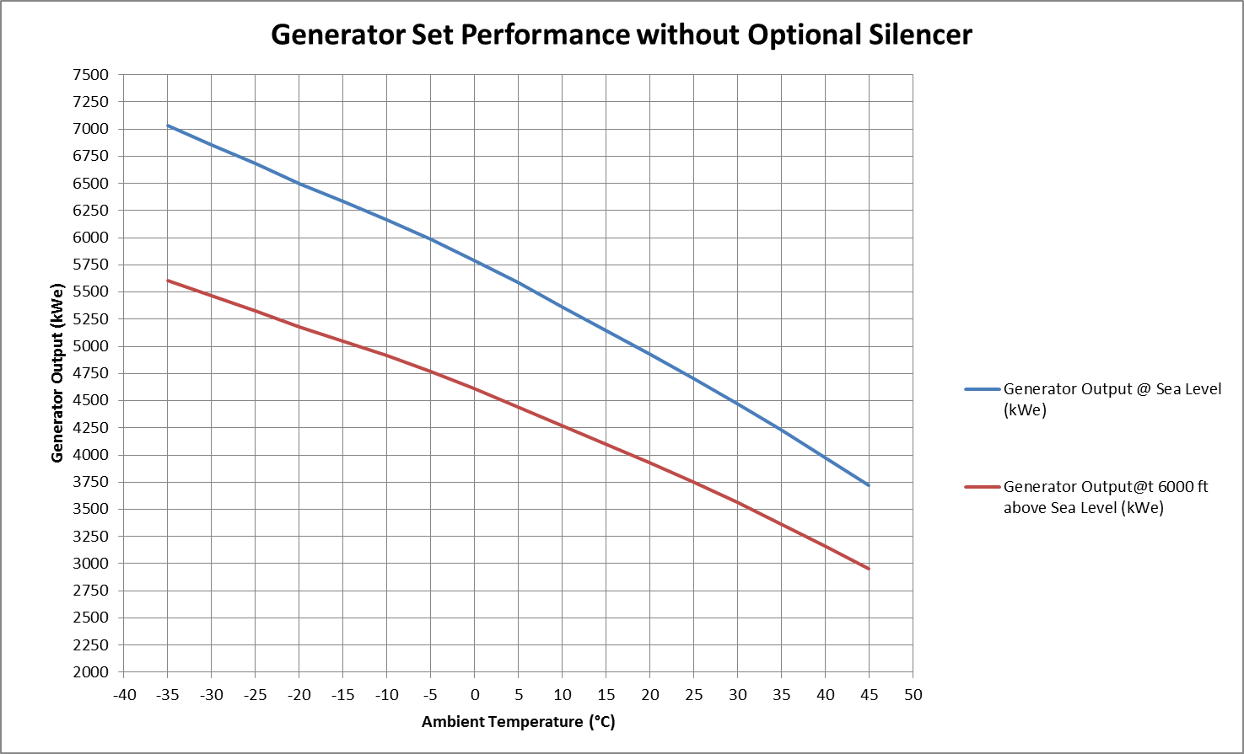

Figure 3.1-1 Max Generator Output Power at Varying Elevation and Temperature

Section 4.0 Technical Descriptions

4.1 Gas Turbine Description
4.2 Speed Reduction Gearbox Description
4.3 Generator Description
4.4 Fluid Systems Description
4.5 Turbine / Generator Control Panel Description
4.6 Switchgear
4.7 Ancillary Equipment

4.0 Technical Description

4.1 Gas Turbine Description

4.1.1 General

The Model 501-KB7S one of the Siemens/Allison 501-K series of industrial gas turbine engines, which have been in production since the early 1960’s. To date, the 501-K series has in excess of 1600 engines in service with more than 30,000,000 operating hours. Operating in continuous duty power generation are more than 680 engines with total operating time exceeding 15,000,000 hours.

4.1.2 Classification

The 501-KB7S gas turbine is a single shaft, simple cycle engine comprised of a high efficiency, 15-stage, axial flow compressor, directly coupled to a 4-stage, internally air cooled turbine sub-assembly operating at a speed of between 14,400 -14,600 RPM, depending on the exact application. The compressor consists of a single stage boost compressor with a compression ratio of 1.5:1 which is directly coupled to a 14 stage core compressor with a compression ratio of 9:1 for a total compression ratio of about 13.5:1. The compressed air flows through a diffuser into the combustion liners where fuel is introduced. There are six combustion chambers of the full flow type assembled within a single annular chamber. The engine incorporates modular construction including completely interchangeable accessory drive sub-assembly and turbine sub-assembly. Each of these assemblies is manufactured to exacting standards with interchangeable parts so as to permit field replacement of sub-assemblies without re-balancing. Each sub-assembly includes its own shafting and bearings. Shafting is constructed with high precision splines to properly mate with adjacent shafting. There are five high quality anti-friction main bearings which are pressure lubricated by an engine mounted pressure lube pump. These bearings are designed to operate without pre-lube or post-lube and with minimum oil consumption and lowest possible heat rejection.

4.1.3 Power Take Off Assembly

The power takeoff shaft is located at the forward air inlet end of the engine. This permits engine to grow toward the exhaust, thus minimizing the problem of engine alignment and provide for thermal expansion. The power takeoff assembly consists of the power takeoff shaft, PTO shaft adapter, mid-bearing assembly, housing and speed pickup assembly. The power takeoff shaft is splined to the compressor extension shaft at one

end and at the other is connected to the driven equipment shaft through a gear type coupling. The coupling is continuously lubricated from the gas turbine lube system. Driven equipment coupling hub is hydraulically shrunk fit onto the driven equipment tapered shaft end. The power takeoff housing encloses the power takeoff shaft and mounts to a specially machined pad on the driven equipment casing. The shear section is designed to protect the turbine in the event of a driven equipment failure or an out-of-sync closure.

4.1.4 Temperature Monitoring

Gas temperature monitoring is achieved through the use of a highly developed system of thermocouples, which measure gas temperature at the outlet of the fourth stage turbine. This location is identified as turbine outlet temperature (TOT). Thermocouples have been developed to operate successfully for long intervals without repairs or maintenance.

4.2 Speed Reduction Gearbox

4.2.1 General

The reduction gear is manufactured by Allen Gear Ltd and is an epicyclic design. It is rated at 8,716 horsepower with a 1.3 service factor at 14,571 / 14,589 RPM input and 1,500 /1,800 RPM output speeds. The gear is designed for direct mounting on the generator end frame. The turbine power take-off assembly is bolted to the high speed end of the gear. The gearcase is of fabricated steel and the top half is removable for ease of inspection.

The basic elements of the Allen gear include a central sunwheel, an internally toothed gear, termed the annulus, a star carrier and star wheels. The star carrier is fixed to the casing. The sunwheel is connected to the high speed shaft (HSS) and the annulus to the lower speed shaft. The annulus and sunwheel rotate in opposite directions. The three (3) star wheels are driven by the sunwheel, which in turn causes rotation of the annulus.

A housing mounting auxiliary gearbox with a roller type overrunning clutch is mounted on the gearbox. The electric start motor mounts to the auxiliary gearbox with the overrunning clutch disengaging the drive at gas turbine self-sustaining speed. A lubrication pump, also mounted to the gearbox, supplies oil to the gearbox, generator and turbine. A seismic vibration pickup is used to monitor the vibration levels of the gearbox.

4.2.2 Speed Reduction Gearbox Specifications

Gearbox Data
Type Epicyclic
Model No. ASG 30
Input Speed (RPM) 14,571 / 14,589
Output Speed (RPM) 1,500 / 1,800
AGMA Service Factor 1.3
Ratio 9.714 / 8.105
Full Load Efficiency (%) 99.0

4.3 Electrical Generator

4.3.1 General

The standard generator offered is an open drip proof type.

Every four pole synchronous generator supplied meets or exceeds the requirements of NEMA standard MG 1, part 22, as well as those of many other national and international standards (such as ANSI, IEC, DIN, etc.).

4.3.2 Temperature Rise

Generator insulation and temp rise ratings are Class “F” (105°C above 40°C ambient).

4.3.3 Stator Core and Frame

The stator core laminations are punched from low loss, non-aging electrical sheet steel. The laminations are coated with C-3 core plate, a heat resistant varnish that insulates the laminations from each other, reducing core losses and improving efficiency.

The core laminations are stacked on through studs, with vent spacers inserted to allow radial cooling of the stator core. A stator head, fabricated from heavy steel plate, is used on each end of the stator core.

The through studs are used to securely compress the core between the stator heads, and the nuts are then welded into place. Heavy tubular steel supports are used to support the core and form a rigid framework.

End frames are fabricated from heavy steel plate, and are attached using heavy tubular steel supports. Mounting feet are welded onto the bottom of the frame, and then the steel outer shell is welded into place, completing the basic stator assembly.

After machining, the slots in the core are filed, and the stator is carefully cleaned to remove metal filings and chips. The completed stator is then ready for the installation of the stator coils.

4.3.4 Stator (Armature) Coils

Since the life of a generator is often determined by the life of the stator coil insulation system, only well proven systems should be employed.

For most applications, we recommend a vacuum pressure impregnated (VPI), sealed insulation system. This system employs mica tape processed with a solventless polyester resin, and an outer layer of fiberglass tape.

After the coil connections are made, they are insulated in the same manner as the stator coils. The stator coil is then preheated, processed through the VPI cycle in Class “H” polyester resin, and baked.

This provides a void free insulation system capable of passing an immersion test per NEMA MG-1 paragraph 20.49.

4.3.5 Rotor Construction

The rotor laminations are punched from special high strength 16 gauge sheet steel, which allows us to meet the NEMA specified overspeed capability of 25 percent while limiting stresses to conservative values.

The laminations are stacked to the required length, then compressed under heavy pressure while the trough studs and rivets are installed.

The copper damper bars are inserted into the pole tips, and the upper coil supports, which hold the field coil end turns in place, are mounted on the studs extending through the pole tips.

The field coils are wound directly onto the pole bodies under tension, using rectangular copper wire insulated with Class “F” Dacron glass and enamel insulation. To fill any voids, epoxy is spread between each layer of the winding.

After the pole connections are made, aluminum wedges are installed between the poles. The wedges hold the field coils in place, and are anchored to the through studs in the spider section of the rotor.

The “balance rings”, which are actually plate steel pieces used to support the outer end of the upper coil supports, are fitted over the studs extending through the upper coil supports on both ends of the poles.

The rotor is baked to cure the epoxy, and is shrink fitted to the shaft while still hot. (The rotor is keyed to the shaft in addition to the shrink fit.)

The fans are then installed and the exciter armature and rectifier are assembled on the end of the shaft. The completed rotor assembly is then dynamically balanced.

The generator shaft material is 1045 or 4145 forged steel, sized to limit shaft stresses to conservative levels.

The bearings are ring oil lubricated split sleeve type.

Spring loaded bearing temperature detectors (100 OHM platinum RTD’s) are installed so that the detector is in contact with the back of the babbitt at all times.

4.3.6 Brushless Exciter

The brushless exciter is a small three phase AC generator mounted on the end of the shaft, whose purpose is to supply current to the generator main field windings. The AC output of the exciter armature is fed to rectifiers mounted on a rotating copper heat sink, and their output is fed directly to the generator main field winding.

The exciter armature core is built using electrical sheet steel laminations, and the armature and field coils are both insulated with Class “F” materials.

4.3.7 Permanent Magnet Alternator

The permanent magnet alternator (PMA) provides power to the generator excitation control system. Since the PMA is independent of the generator stator windings, it provides sustained output power to the excitation control system for field forcing during fault conditions.

As the name implies, the PMA field poles are permanent magnets, which guarantees an output from the pilot exciter armature as long as there is rotation. The PMA is mounted on the generator shaft, directly behind the exciter.

4.3.8 Accessories

Every generator is furnished with stator temperature detectors (two per phase), space heaters, copper grounding pads on two corners of the frame, an oversized main terminal box, and separate auxiliary conduit boxes for RTD, space heater, exciter field and PMA leads.

4.3.9 Testing

Each generator receives the following minimum tests (performed in accordance with IEEE standard 115):

a) Polarity check of field coils, DC voltage drop test
b) Measure air gap
c) Check no-load excitation current and voltage
d) Check voltage balance
e) Measure and record winding resistance

f) Verify correct phase rotation
g) Measure sound level
h) Balance rotor to .001” displacement, run Overspeed test at 125% speed, re-check balance
i) High potential test
j) Check insulation resistance

4.3.10 Electrical Generator Specifications

General Data
Nameplate Rating at 40°C, (kVA)……………………….. 5,250
Rating at 40°C, 0.90 P.F. (KW)………………………….. 4,750
Frequency (HZ)…………………………………………… 60
Voltage (L-L)………………………………………………. 2,600
Sub-Transient Reactance (X”d) ……………………… 0.188 pu kVA
Efficiency at Full Load …………………………………… >96.5%
Speed (RPM……………………………………………….. 1800
Insulation System ……………………………………….. VPI
Insulation …………………………………………………. Class “F”
Temperature Rise ………………………………………… Class “F”
Waveform Deviation (Max) ……………………………… 10%
Telephone Influence Factor, Balanced/Residual (TIF) 40/50
Voltage Harmonic Content (Max)**……….. 5% Total with No Single Exceeding 3%
Overload Capacity…………………………150% Current for 1 Minute 110% of Rated for 2 Hours Out of 24 Hours
Reactance, time constant and efficiency data vary with the voltage and frequency selected.
**The 5% and 3% voltage harmonic content refers to the amount of harmonic distortion that the generator can produce. The generator has been selected based on its ability to handle 30% THD (total harmonic distortion).

4.3.11 Generator Neutral Grounding

The Generator WYE point (Neutral) is connected to GTG Frame Ground through a high resistance Transformer/Resistor arrangement configured to limit ground fault contribution of the Generator to < 10 amps. Standard high resistance neutral ground systems are rated for 10 seconds at rated GFC. GFC current will be monitored and protective trip employed to

4.3.12 Generator Local Power Distribution

For this Haliburton mobile power application, Generator Lines will be directly connected to the Bus of an on-board Switchgear lineup consisting of three (3) Siemens Feeder Circuit Breakers. Feeder Breaker Switchgear will be provided with protection relaying for each Feeder output as well as Generator protection. Connections for MV output lines from the Feeders will be via quick disconnect 3-phase connectors (2 per Feeder output).

An on-board 2.6kV:460Vac auxiliary transformer will be provided, connected to the Generator bus through a fused disconnect switch, to provide onboard supply of GTG operating 460V, 240/120Vac and control power parasitic loads once the GTG has attained operating speed and voltage.

4.4 Fluid System Descriptions

4.4.1 Gas Fuel System

The standard generator set is fueled by natural gas with dry low emissions combustion system. Fuel metering is accomplished by electronically actuated fuel metering valves (GFV-10 & 11), which provide excellent response characteristics that in turn provide rapid generator transient response. The natural gas system is designed for automatic operation. All piping and valve trim is of stainless steel, a skid inline filter is provided.

The generator set will operated satisfactorily on natural gas fuel, conforming to Rolls-Royce Allison specification.

The Natural Gas Fuel System major components included with the package are:

- 10 micron filter, inline
- Primary fuel shutoff valve
- Secondary fuel shutoff valve
- Pilot gas fuel manifold
- Main gas fuel manifold
- Gas fuel nozzles
- Electronically controlled gas fuel metering valves.
- Gas fuel shut off valves, pilot and main fuel manifolds
- High and low pressure alarm/shutdown transmitters and/or switches
- Pressure gauges

To reduce NOx emissions the gas turbine will be equipped with a dry low emissions system (DLE). The DLE system is a dual combustion zone system with pilot and main modes. The pilot mode is a standard diffusion flame type system for starting the gas turbine and the main mode is a lean pre-mix system. Fuel and air are mixed prior to introduction into the main portion of the combustor. The pre-mixing results in a relatively low average combustion temperature, resulting in low NOx emissions.

The gas fuel is controlled by two skid mounted redundant shutoff valves (PV-10 and PV-11) and gas fuel metering control valves (GFV-10, pilot & GFV-11, main). PV-10 is an air operated three-way (block and bleed) type valve which vents any trapped gas between the two shutoff valves. PV-11 is an air operated two-way valve. Shutoff valves are controlled by air from quick exhaust solenoid valves (PY-10, PY-11). The fuel control valves and the fuel shutoff valves are positioned as a function of electronic signals received from the turbine generator control panel fuel control system. The fuel control valves provide a valve position feedback and Mass Flow (4-20 mA) signals to the control system
which monitors and displays the valves position and flow rate.

The condition of the fuel filter element is displayed by the indicating differential pressure switch PDI-11.

4.4.2 Lubrication Oil System

The generator set includes a common lubrication system for the turbine, gearbox and generator. A common reservoir and cooler are utilized although the lubrication system for the turbine operates at a different pressure level than the gearbox and generator. Both systems are completely compatible with the synthetic lube oil.

Lube oil is drawn from the reservoir by the gearbox-mounted, shaft-driven pump. The oil is then delivered to the gearbox, generator and turbine through the cooler mounted thermostatic valve (TCV-40), duplex cooler (C-30/31) and duplex filter (F-40). The oil is directed through the cooler only when the thermostatic valves sense the oil temperature approaching 49°C (120°F). Oil supply to the turbine is delivered through a pressure regulator before connecting with the auxiliary gearbox driven pump. This pump provides oil to the required points of lubrication, such as the turbine bearings. Engine driven scavenge pumps return the oil to the oil reservoir. In addition, oil is also supplied by the gearbox driven pump to lubricate the outboard end of the P.T.O. shaft. Turbine oil pressure is controlled as indicated (PI-30) and monitored (PT-30) with alarm and shutdown signals provided at the Operator Interface Unit (OIU).

Oil delivered to the gearbox and generator by the gearbox driven pump is pressure controlled by a backpressure control valve (PCV-40), while the pump is protected by an integral relief valve, in case of line blockage. Both pressure (PT-40) and temperature (TE-41 & TE-42) are monitored and an alarm or shutdown is activated should any abnormal operating conditions be detected in this lubrication circuit.

An A.C. motor driven coupled pump (P-31) provides pre-lubrication to the turbine, gearbox, generator and starting motor housing during start-up.

The lube oil reservoir includes immersion heaters (HE-40 & HE-41) to maintain the reservoir temperatures at approximately 26°C (80°F) when the unit is not operating. A level transmitter (LT-40), level indicator (LI-40) and temperature sensor (TE-40) are also installed in the reservoir. The level transmitter interfaces with the control panel and will indicate level is low at the operator interface unit (OIU).

4.4.4 Fire Suppression System

A Carbon Dioxide (CO₂) fire suppression system is supplied to protect the generator set in the unlikely event of an enclosure fire. The system has been designed to comply with NFPA Standard 12 (Carbon Dioxide Extinguishant Systems).

The system consists of a control panel mounted fire system controller, unit mounted thermal and ultra-violet fire sensors, CO₂ cylinders and associated piping and nozzles. When an excessive temperature or flame is sensed, the controller will initiate a turbine shutdown. The following sequence of events will then be followed: The fuel valves are closed, all pumps and vent fans are stopped, air inlet and exhaust louvers are closed, strobe lamps will come on, and the lube oil immersion heater will be disabled and the turbine bleed air valves are held closed. A pneumatic device delays the actual discharge of CO₂ into the enclosure for approximately 10 seconds to provide for personnel egress. “CO₂ Released” and “Fire” are annunciated at the turbine control panel.

The Fire System Controller is located in the turbine generator set control panel, and is powered by 120 VAC with a backup battery. The ultra violet and thermal sensor circuits are continuously monitored by the panel.

The U-V and thermal detectors in the generator enclosure are wired into a common dedicated detection circuit which is continuously supervised to monitor sensor operations and malfunctions.

The controller for the gas monitoring system is mounted on the front of the turbine control panel. Two independent channels are continuously monitored for potentially explosive concentrations. Both channels share three alarm circuits and LEDs indicating high concentration (60%), low concentration (30%), and system malfunction.

The CO₂ extinguishing system consists of CO₂ cylinders with distribution piping and discharge nozzles. The extinguishing system is a total flooding type designed to maintain a minimum CO₂ concentration for an extended period of time.

The discharge of carbon dioxide in a fire extinguishing system creates possible serious hazards to personnel. Flashing strobe lights are provided on top of the enclosure to signal when CO₂ is being released while in addition to this a discharge horn is provided inside the turbine enclosure. Appropriate warning signs are also affixed outside of the turbine generator enclosure.

4.4.5 Electric Start System

The Electric Start system consists of 175 HP (130 KW) four-pole electric motor mounted on the unit’s epicyclic load gear through an overrunning clutch. The start motor is controlled via an inverter that combines the function of a motor starter with the use of pulse width-modulating switching transistors, to convert a constant power-constant frequency input into a variable power-variable frequency output.

When a turbine crank signal is initiated, the inverter will energize the start motor which will begin to turn.

During the turbine start cycle, as the start motor begins to rotate, the overrunning clutch automatically engages to transfer the motor’s torque to the generator set drive train. The starter accelerates the unit through ignition speed and continues to assist the gas turbine up to starter cut-out speed. When the gas turbine reaches starter cut-out speed, the inverter control de-energized the motor. The gas turbine then continues to accelerate on its own up to rated speed, the overrunning clutch having automatically disconnected the start motor when the power supply was switched off.

4.4.6 Combustion & Ventilating Air Flow System

The turbine combustion air is filtered by an integrated filter assembly. The filtered combustion air passes through silencing ducting to a package inlet plenum directing the air into the gas turbine. The plenum has a removable plate to enable access for the mandatory inlet inspection. The combustion air is exhausted through a set mounted diffuser and expansion joint.

The generator package cooling and ventilating air is drawn from an integral filter assembly. Generator cooling air is drawn through the generator by fans mounted on each end of the generator shaft. The cooling air is discharge through an opening in the bottom of the generator and discharged into the turbine area. The remaining ventilating air not used by the generator flows through the generator area, over the gearbox and into the turbine enclosure where it mixes with the generator discharged air. The ventilating air exits the generator package through turbine mounted exhaust eductor or enclosure through a louvered opening in the roof and is ducted through exhausted away via a rain shield type hood.

Automatically operated louvers are included at the inlet and outlet of the cooling and ventilating air. These louvers operate to retain fire extinguishant in case of fire and to eliminate airflow through the enclosure when the unit is not operating.

4.4.7 Water Wash Cleaning System

The water wash system helps maintain a clean compressor for efficient operation. The gas turbine inlet plenum is fitted with two sets of spray manifolds. One set consists of a set of four atomizing spray nozzles, and is used for a running water wash. The other set consists of four narrow cone spray nozzles, directed into the engine bell mouth, and is used for crank soak water wash. A 3-way valve is located within the turbine generator enclosure to direct the cleaning/rinse agent between crank soak and running wash manifolds. A water wash manifold is also installed in the core compressor intake consisting of 6 spray nozzles located in the bleed duct flange just aft of the boost compressor. An additional 3-way valve is located within the enclosure to switch from the intake plenum to the core compressor spray nozzles. Shut off valve, drain valves, and an inline filter are also included.

A portable water wash cart is provided which consists of a ten gallon tank, an electric motor driven pump, a filter, and a gauge and pressure control valve. The cart supplies cleaning solution and rinse water to the turbine skid through a hose and quick-disconnect fitting, at the proper pressure and flow rate.

4.4.8 Instrument Air System

Instrument air is used to operate the engine mounted bleed valves, the ventilation louvers and various valves in the fuel system.

During the start sequence the ventilating louvers are opened to provide for the enclosure purge. A 3-way solenoid valve PY-52 operates to direct air to the louver cylinder operators. When the valve is energized the cylinder rod ends are pressurized and the cylinder head ends are vented retracting the cylinders and opening the louvers. The louvers remain open while the unit is operating. When the turbine is shutdown the louvers are closed after the cool-down period is completed. PY-52 is de-energized causing the actuator cylinder rods to extend closing the louvers.

The fifth and tenth stage compressor bleed valves and boost stage bleed valve are closed by a signal from the fuel management system during startup as a function of speed. During startup the valves are open. The valves are closed at approximately 13,200 RPM. During a shutdown the valve opens as soon as the fuel shutoff valves close. Air to the bleed valves is controlled by the 3-way air operated ball valve (PV-50) which is operated by a solenoid (PY-50). In case of an enclosure fire the bleed valves are re-closed during shutdown (below 4000 RPM) and they remain closed until the fire control panel is reset. The valves are also closed during a crank soak water wash cycle. Normally, however, the bleed valves are open when the unit is not operating.

In addition to the valves, the instrument air system also includes a gauge (PI-50) and a low pressure alarm switch (PSL-50).

Instrument air supplied to the skid must conform to 3 micron filtration, 10 SCFM, (90-100 psig), -10°F dew point.

4.4.9 Instrumentation System

A number of electrical devices are mounted on the turbine generator package that provide input signals to the turbine generator control system.

Two magnetic speed pick-ups (ST-60 & ST-61) are mounted on the turbine. One pick-up (ST-61) is located on the power take-off shaft housing and is excited by a forty-tooth gear. The other speed pick-up (ST-60) senses the passing of the fifth stage compressor blades (41). Both units provide speed signals to the PLC.

Twelve dual element chromel-alumel thermocouples (TE-60A &TE-60B) are mounted in the turbine case to sense the turbine outlet temperature. Each set of the dual elements are averaged and wired to the PLC and are used to calculate control temperature.

Two resistance temperature detectors (TE-66A& TE-66B) are mounted in the turbine compressor air inlet housing. These devices are wired to the fuel management system to provide an ambient temperature bias.
Two Velocity pickups are mounted on the generator, one on the drive end (VE-63) and one on the non-drive end (VE-64). One Accelerometer on the gearbox case (VE-62) and one Velocity pick-up on the turbine case (VE-60) are also provided. The velocity pickups are wired to the PLC monitored vibration monitor.

There are a pair of three 100 ohm platinum resistance temperature detectors (TE-68A, B, C & TE-69A, B, C) in the generator stator windings (two in each phase). Three of these RTDs are wired to the PLC. The other three (one per phase) are available as spares. RTDs are installed in each generator bearing (TE-66 & TE-67) in the generator thrust bearing (TE-64, 65) and the turbine enclosure (TE-62).

All input values reside within the PLC and can be read out on the OIU vibration and temperature screens. Alarm and shutdown levels are also stored in the PLC. If the transmitted values exceed the stored set points an alarm is indicated on the alarm screen. If a danger level is reached the turbine generator is shut down and the fault is illuminated on the shutdown annunciator screen.

A space heater (H-60) is installed in the generator to prevent the formation of moisture due to condensation when the unit is not operating.

Differential pressure transmitter (PDT-60) is installed on the unit to monitor the pressure drop across the combustion inlet air filter system and provides warning and shutdown functions. A gauge, PDI-110 provides visual indication of the pressure drop across the filters.

The exciters (EY-60 & EY-61) for the spark igniters (EN-60 & EN-61) are mounted on the gas turbine. The exciter is a capacitive discharge device that converts the 24 VDC battery power to the high voltage, high energy source which operates the two spark igniters. The igniters are grounded and require the negative side of the 24 VDC source to be grounded for proper operation.

A pressure transmitter (PT-60) is also provided to indicate compressor discharge pressure. This signal can be read out on the OIU and is used as a turbine diagnostic tool.

4.5 Turbine / Generator Control Panel Description

4.5.1 System Overview

This microprocessor based control system is designed for Siemens 501-K product line. The heart of this system is a high speed programmable logic controller (PLC). The program can be modified to accommodate special project requirements at the factory or in the field as site requirements change. The program is stored in non-volatile EEPROM memory. Internal diagnostics, LED status indicators and modular components simplify troubleshooting and maintenance of the control system.

The color operator interface unit (OIU) incorporates the same memory and configuration features as the PLC. It displays all information required for normal operation and maintenance of the generator set.

The generator control is achieved with a digital AVR/FCR excitation control sequenced by the PLC. Dedicated power meters are used to locally display generator parameters in addition to the CRT displays.

4.5.2 Fuel Management System

This system is configured for isochronous type speed control. In Isochronous operation the Temperature and KW Limiting controls (below) are automatically set to maximum allowable limits. Droop type speed-load control is also provided. All fuel management parameters described below function on a least-wins basis, that is the parameter that demands the smallest quantity of fuel is always in control.

Speed Control. The gas turbine runs on speed control prior to the generator circuit breaker (52G) closing or when operating isolated from a larger power source. Two (2) speed sensors (magnetic pickups) are located on the high speed train - One (1) on the gas turbine and one (1) on the power takeoff (PTO) shaft. The higher of the two signals is selected for control in the Fuel Management System (FMS). The FMS adjusts the output to the fuel metering valves (FMVs) to maintain constant speed for precise generator frequency control.

The speed adjustment is used to adjust generator frequency during manual synchronization or when operating isolated from a larger source.

The speed control provides excellent system performance as follows:

Steady State Control ±0.25%
Transient Speed Deviation ±5%
(Upon Application or Rejection of 3000 KW)
Transient Recovery Time 3 Seconds

Temperature Control. The gas turbine may be limited by temperature control when operating in parallel with a larger source. Temperature is measured with twelve (12) dual element type K thermocouples placed in the outlet of the 4th stage turbine. Both sets of twelve (12) thermocouples are parallel connected which provides two (2) average turbine outlet temperature (TOT) signals. The FMS selects the higher of the two TOT signals for all control system functions. Calculated turbine inlet temperature (CTIT) is computed by the FMS based on TOT, compressor inlet temperature (CIT) and engine speed. The FMS adjusts the output to the FMV to maintain constant CTIT so that the generator set will produce its maximum continuous output rating automatically. Temperature control is active in both Isochronous and droop control. Temperature control is primarily used to control closed-loop Start Temperature limiting and is automatically ramped to maximum allowable operating temperature when operating in Isochronous/isolated mode.

KW Limiting. The gas turbine may run on the KW limiter when operating in parallel with a larger source. KW limiting is active whenever the generator circuit breaker is closed. When operating in Isochronous/isolated mode, KW Limiting setpoint is ramped to maximum allowable SHP limit of the drive train components.

Some applications require operation at a fixed or maximum KW set point. The SLRLS can be used to adjust the KW set point to any value within the capability of the generator set.

4.5.3 Control Logic

Start Sequence. The control system is designed to start and load the generator set automatically upon receipt of a local or remote start command. This system also allows manual operation of Load Feeder Breakers and loading sequences if desired. Assuming the generator set is in a “ready to start” status i.e. there are no standing shutdown indications and the mode selected is “normal”, the following occurs upon receipt of a start command:

1. The enclosure purge sequence begins

2. After a 30 second enclosure purge, the pre/post lube pump is activated, and an exhaust system purge sequence begins (on gas fueled units) by activating the starter which spins the turbine at 4000 RPM for approximately 5 minutes (dependent upon exhaust system volume) after which the starter is de-activated and the turbine decelerates.

3. At 1,800 RPM, the starter is re-activated and acceleration begins.

4. At 2,200 RPM, fuel and ignition turn on and acceleration continues, assisted by the starter and combustion in the turbine.

5. At CTIT >315°C (600°F), the start counter registers an engine start.

6. At 10,500 RPM, the ignition and start systems are de-activated and the running hour meter is enabled. The voltage regulator (AVR) is also enabled with its frequency compensated set point at nominal Generator rated voltage.

7. At 13,200 RPM, the turbine compressor bleed valves close and the pre/post lube pump is de-activated.

8. At 14,571/14,589 RPM, the speed governor assumes control of the turbine and maintains synchronous speed (50/60 HZ).

9. At 10 seconds after 13,000 RPM, and with speed and voltage within allowable operating tolerances and with internal verification that the GTG transfer to internal auxiliary power has successfully occurred, the OIU displays “ready to load” status and output Feeder Breaker operation is enabled.

Normal Operation. After the start sequence is completed, the turbine generator set will continue automatic operation in the control modes described in the fuel and excitation control sections. The control system continuously monitors the turbine generator set for abnormal conditions. If a malfunction is detected, the warning and/or shutdown condition is annunciated and an appropriate sequence is initiated.

Normal Shutdown. With the turbine generator set operating normally as described above, the following occurs upon receipt of a stop command, local or remote:

- 52G opens and the turbine continues to operate at no load for five minutes.
The open command is issued immediately to any/all three output Feeder Circuit Breakers that are indicating closed position upon receipt of a Normal stop command and the Turbine continues to operate at no load for five minutes (Cooldown sequence). At any time during the five minute cool down time, the GTG stop sequence can be reset to normal operating condition by re-initiating the start command.

- Upon expiration of the five minute cool down timer, turbine fuel and generator excitation are turned off. The engine decelerates and voltage decays.

3. At 13,400 RPM the GT compressor bleed valves are opened and the running hour meter is deactivated.

4. At 2,200 RPM, the turbine generator set can be safely restarted. Assuming no malfunction shutdown conditions exist, ready-to-start status is displayed and the control system will accept a new start command.

Malfunction Shutdown. This sequence is initiated by any of the shutdowns indicated on the malfunction shutdown list. It is identical to the normal shutdown sequence except there are no delays to unload the generator and cool down the turbine. Immediately upon detection of a malfunction, turbine fuel and generator excitation are deactivated, all output Feeder Circuit Breakers are opend and the malfunction is annunciated. The malfunction condition must be cleared and the control system reset before a new start command is accepted.

For Malfunction Shutdowns emanating from the MV system protection relaying, a Generator Exciter discharge resistor shall also be activated as part of the sequence.

4.5.4 Vibration Monitoring System

The vibration monitoring system is mounted in the control panel and communicates with the PLC through a combination of hardwired and communication interfaces.

Key information such as vibration levels and alarm set points are displayed on the OIU. The front panel of the vibration monitor contains communication interface, system diagnostic and raw signal ports. There are four seismic pickups provided, one on the turbine case, one on the gearbox high speed input shaft case and one on each generator bearing housing.

4.5.5 Temperature Monitoring System

Sensors (100 OHM RTDs) from various systems are connected to the PLC. Temperature levels and alarm set points are displayed on the OIU. The points monitored as standard are indicated on the malfunction shutdown and warning list, temperature high summary.

4.5.6 Excitation Control System

The excitation control system is designed to control generator excitation under all operating conditions. This system is comprised of a digital automatic/manual voltage regulator which provides soft start, VAR/P.F. control and min/max excitation limiters.

Voltage Regulators. This device maintains generator output voltage at a desired set point. It features voltage set point frequency compensation and quadrature current compensation for reactive load control.

The generator operates in the voltage control mode prior to 52G closure or when operating isolated from a larger power source. Three phase voltage is sensed at 120 VAC nominal PT inputs. The voltage regulator (V.R.) adjusts the output to the exciter

field to maintain the voltage set point. The V.R. set point input is programmed within the AVR and adjustable (±10%) by the voltage raise lower switch (VRLS) through the PLC.

The excitation control system, combined with the generator excitation system and PMA (permanent Magnet Alternator) provide excellent voltage control characteristics as follows:

Steady State Control ±0.5%
Transient Voltage Deviation ±17%
(Upon Application or Rejection of Generator Nameplate Rating)
Transient Recovery Time 1 Second
(To within 5% of Rated Voltage)

VAR/PF Control. This control maintains constant generator output VAR or PF level when operating in parallel with a larger power source such as a utility. The VAR/PF Control achieves this by biasing the V.R. set point, thus controlling the output to the exciter field. A VAR/PF level setting and selector switch are accessible at the front of the control panel.

4.5.7 Synchronization System

This system includes manual and automatic capability. Synchronization (auto or manual) may occur assuming the generator set has been started, achieved “ready-to-load” status and the supervisory sync check relay has been satisfied.

Manual Synchronization. Manual synchronization is performed by the operator utilizing the generator instruments and control switches located on the front of the turbine generator control cabinet. After placing the auto-manual sync switch (43AS) in the manual position, the operator must take the following steps:

1. Adjust generator voltage with the voltage raise lower switch (VRLS) to match bus voltage.

2. Adjust frequency with the speed load raise lower switch (SLRLS) to match bus frequency and phase angle relationship by viewing the synchroscope.

3. Close the generator circuit breaker (52G) by operating the breaker control switch (52CS).

Manual Dead Bus Closure. To close 52G when the bus is de-energized, the dead bus relay section of the sync check relay must be satisfied.

Automatic Synchronizing. Automatic synchronizing is performed by the automatic synchronization in conjunction with the PLC (frequency control) and voltage regulator (voltage control).

It is initiated by placing 43AS in the “automatic” position. The same steps take place as described under manual synchronization except that voltage, frequency and breaker control commands are given by the PLC/AVR. Sync-check is performed by a separate device provided within the control panel.

4.5.8 Control Power System

This system provides the 24 VDC control power for the entire turbine generator control system. It is sized to provide DC power to the control system for four hours upon loss of AC power and recharge to full reserve capacity in eight hours. It is comprised of the following components:

Batteries. Lead acid, recombination non-gassing type with a 20-year life expectancy. Batteries have been upgraded to operate down to at least -35°C.

Battery Charger. Includes a DC ammeter and voltmeter, AC power and DC current failure alarm and low noise filtering. Cabinet is designed for wall mounting.

Battery Rack. Single tier, floor mount type.
Malfunction Shutdown and Warning List

Malfunction Shutdown List

Point Active Sensor

1) Fire Always FDC
2) CO₂ Released Always PSHH-90
3) Gas Detected Always GDM
4) Emergency Stop Always E-Stop PB’s
5) Electrical Fault Always 86G
6) PLC Malfunction Always PLC
7) Turbine Start Stagnation Always ST60, ST61
8) Turbine Fail-to-Crank 30 Seconds after Starter Enable ST60, ST61
9) Turbine Fail-to-Fire Gas Fuel On +5 Seconds TE60A, TE60B
10) Turbine Underspeed <13,000 RPM +1 Sec. & Fuel On ST60, ST61
11) Turbine Overspeed Always ST60, ST61
12) Turbine Overtemp Always TE60A, TE60B
13) Backup S/D Always OSS, ST60, Watchdog
14) Low Turbine Lube Pressure >13,000 RPM PT30
15) Low Gearbox Lube Pressure >13,000 RPM PT40
16) Temperature High Summary
Gen Stator – Phase A Always TE-68A
Gen Stator – Phase B Always TE-68B
Gen Stator – Phase C Always TE-68C
Generator Drive-End Bearing Always TE-66
Generator Non-Drive End Brg Always TE-67
Generator Thrust Bearings Always TE-64, TE-65
Lube Supply Always TE-41
Lube Reservoir Always TE-40
Gearbox Lube Return Always TE-42
Skid Enclosure Always TE-62
17) Vibration High Summary
Gearbox Case Always VE-62 Velocity
Generator Non-Drive End Shaft Always VE-64 Velocity
Generator Drive End Shaft Always VE-63 Velocity
Turbine Case >13,000 RPM +10 Seconds & Fuel On VE-60 Velocity
18) Combustion Air Filter Always PDT-60
Differential Pressure High
19) Gas Fuel S/O Valves Malf. 30 Seconds after Gas Fuel Shutoff PSHH-15
Valves are Closed until Opened
20) Fail to Pre-Lube Pre/Post Lube Pump On +10 Seconds PT-30

Malfunction Warning List

Point Active Sensor

1) Fire Detection Malfunction Always F&GM
2) Gas Detection Malfunction Always F&GM
3) Gas Detected Always F&GM
4) Failure to Synchronize Auto Synch Initiated +60 Seconds
5) PLC Malfunction Always PLC
6) Turbine Lube Magnetic Chip Always CS-30
Detected
7) Lube Oil Reservoir Level Low Always LSL-40
8) Lube Filter Diff. Pressure High Always w/ 15 Second Delay PDSH-40
9) DC Circuit Breaker Trip Always All DCB’s
10) Turbine Overspeed Always ST60, ST61
11) Turbine Overtemperature Always TE60A, TE60B
12) Low Instrument Air Pressure Always PSL-50
13) Turbine Lube Pressure Low >13,000 RPM PT-40
14) Gearbox Lube Pressure Low >13,000 RPM PT-30
15) Temperature High Summary
Generator Stator A Always TE-68A
Generator Stator B Always TE-68B
Generator Stator B Always TE-68C
Generator Drive-End Bearing Always TE-66
Generator Non-Drive End Brg Always TE-67
Generator Thrust Bearing Always TE-64, TE-65
Lube Reservoir Always TE-40
Lube Supply Always TE-41
Gearbox Lube Return Always TE-42
Skid Enclosure Always TE-62
16) Vibration High Summary
Gearbox Case Always VE-62
Generator Non-Drive End Shaft Always VE-64
Generator Drive End Shaft Always VE-63
Turbine Case >13,000 RPM +10 Seconds and Fuel On VE-60
17) Combustion Air Filter Diff. Always PDT-60
Pressure High
18) Gas Fuel Pressure High Always PT-11
19) Gas Fuel Pressure Low Always PT-11
20) TOT Sensor Malfunction Always TE60A, TE60B
21) Cooling Air Filter Diff. Pressure Always w/ 15 Second Delay PDSH-111
High
22) Control Battery Charger Malf. Always Battery Charger
23) Fuel Last Chance Filter Diff. Always PDSH-12
Pressure High
24) U.V. Fire Detection Inhibited Always F&GM
25) CO₂ Release Disarmed Always F&GM
26) Electrical Fault >13,000 RPM +10 Seconds 94G

4.6 Switchgear

Siemens NXPLUS C 8DA (single bus) and 8DB (double bus) medium-voltage, gas-insulated, arc-resistant switchgear with the following features and benefits:
- Up to 38 kV, up to 40 kA
- Compact - up to 80 percent smaller than air-insulated switchgear
- Well suited for contaminated environments
- Single-phase design eliminates phase-to-phase faults inside the switchgear
- Significantly reduced PPE needs
- Vacuum interrupter - up to 30,000 mechanical operations
- Low pressure SF₆ gas-insulated for insulation only (not for interruption)
- 20-year internal maintenance cycle
- UL or C-UL Listing available (consult factory)
- Meets or exceeds the latest standards:
  - IEC 62271-200 high-voltage switchgear
  - IEC 62271-1 high-voltage common requirements
  - ANSI/IEEE C37.20.2 (where applicable) metal-clad switchgear
  - ANSI C37.55 (where applicable) conformance tests
  - Arc-resistant to ANSI/IEEE C37.20.7, up to 40 kA, 0.5 sec, accessibility type 2B
  - IEC 62271-100 high-voltage circuit breakers
  - ANSI/IEEE C37.04 rating structure for high-voltage circuit breakers
  - ANSI/IEEE C37.09 high-voltage circuit breaker testing
  - ANSI/IEEE C37.06 preferred ratings for high-voltage circuit breakers
  - ANSI/IEEE C37.010
  - ANSI C37.54 (where applicable) conformance tests
  - IEC 62271-102 – disconnectors and earthing switches.

The switchgear compliments to prototype mobile genset design in that it provides the best solution for the least amount of space claim which is at a premium in this configuration. In addition, the latest safety standards are met and the personal protective equipment requirements are reduced by the use of the hermetically welded stainless steel enclosures

4.7 Ancillary Equipment

Structural Baseplate
The turbine generator baseplate is fabricated from formed plate welded one piece structure. The design has been developed to be torsional stiff and therefore lighter in weight than most typical standard shape bases. Baseplate structures are free of any system natural frequencies within operate speed range.

All external welds are continuous seam welds. The machinery mounted surface pads are placed with an accurate fixture and secured to the base structure using fast chock exposy.

Enclosure
The enclosure is a post and beam type, all-bolted assembly consisting of standard corners, posts, sills, roof sections, wall sections and doors. All exterior members are aluminum painted in accordance with OPI Protective Coating Specification. Doors and wall sections are filled with fire retardant insulation and covered with corrosion resistant, perforated metal on the inside. The hinges and fastening hardware for the enclosure doors are of stainless steel construction. Each door is equipped with a key lock type latch.

The roof structure is designed with aluminum sheet and welded to structural shapes painted in accordance with OPI Protective Coating Specification.

Lighting
Each gas turbine generator skid comes complete with four (4) vapor tight light fixtures and two (2) 120 VAC convenience receptacles. The control cabinet has one (1) 40-watt fluorescent light fixture and one (1) 120 VAC convenience receptacle.

Sound Attenuation
The enclosure is designed to achieve a free-field weighted noise level of 85 dBA or less, at a distance of 1.0 M (3 Feet) from the side of the enclosure, at an elevation of 1.5 M (5 Feet) above grade. Additional silencer sections (2-15’ Lg.) will be provided to meet specification far field dBC noise levels. Extensions to mount to top side of generator trailer.

Exhaust System
The exhaust system includes a stainless steel low loss diffuser/transition assembly with an aft facing vertical, rectangular cross section flange an a stainless steel bellows/or fabric type expansion joint for connection to the stainless steel parallel baffle type silencer.

The diffuser to engine tailpipe will be by means of a slip joint to allow for engine thermal growth.

Generator Set Lifting Fixture
A gas turbine generator unit lifting assembly is furnished, including a lift fixture assembly, lifting devices and wire rope slings, to lift the gas generator package from the trailer if needed.

Five-Axle Transport Trailer

The complete mobile gas turbine generator package and turbine exhaust silencer is mounted to a single triaxle trailer which also supports the common lube oil storage reservoir. This trailer has air ride suspension system and sized for transporting 80,000 Lbs. (Estimated unit weight).

Portable Cable Couplers Plugs-Receptacles

Each trailer mounted GTG will be equipped with two electrical plug couplers for interconnecting to the pump trailers. H.V. Plug connector will be a TJB PLM3A suitable for mating with a TJB SFG3B female socket cable from the pump trailers.

5.1 General Arrangement Drawing
Double click image for better resolution.

5.2 Typical Piping and Instrumentation Diagrams
Double click images for better resolution.

5.3 Typical Electrical Utilities Load List

5.4 Typical Non-Electric Utilities Load List

5.5 Document List

A.) Arrangement and Installation Drawings

- General Arrangement Gas Turbine Generator Set
- Foundation Plan Gas Turbine Generator Set
- Gas Turbine Generator Set Installation

B.) System Schematic Diagrams

- Gas Fuel with Water Injection System Schematic and Bill of Material
- Lubrication System Schematic and Bill of Material
- Instrument Air System Schematic and Bill of Material
- Instrumentation System Schematic and Bill of Material
- Electric Start System Schematic and Bill of Material
- Fire Suppression and Gas Detection System Schematic and Bill of Material
- Air Flow System Schematic and Bill of Material
- Water Wash System Schematic and Bill of Material
- Fluid Systems Schematic Legend

C.) Electrical Schematics and Diagrams

- Turbine Generator Single Line Diagram
- Electrical Interconnect Diagram
- Electrical Interconnect Wire List
- Master Control Schematic
- Standard Device Schematic Legend
- Turbine Generator Control System Specification

D.) Utility Requirements

- Electrical Requirements
- Non-Electrical Requirements

E.) Specifications / Reports / Manuals / Schedules

- Quality Plan and Documentation Test Report
- Protective Coatings Specification
- Gas Turbine Generator Set Package Performance Curves
- Piping Specifications
- Wiring Specifications
- Production Schedule
- Production Test Plan
- Factory Test Report (Optional)
- Operations and Maintenance Manuals
- Recommended Spare Parts List
- Kit Lists ( Shipped Loose Parts)

Appendix A: Attachments

The following attachments are provided with the proposal:

General Arrangement Drawing

General Arrangement Drawing with Optional Exhaust Silencer

